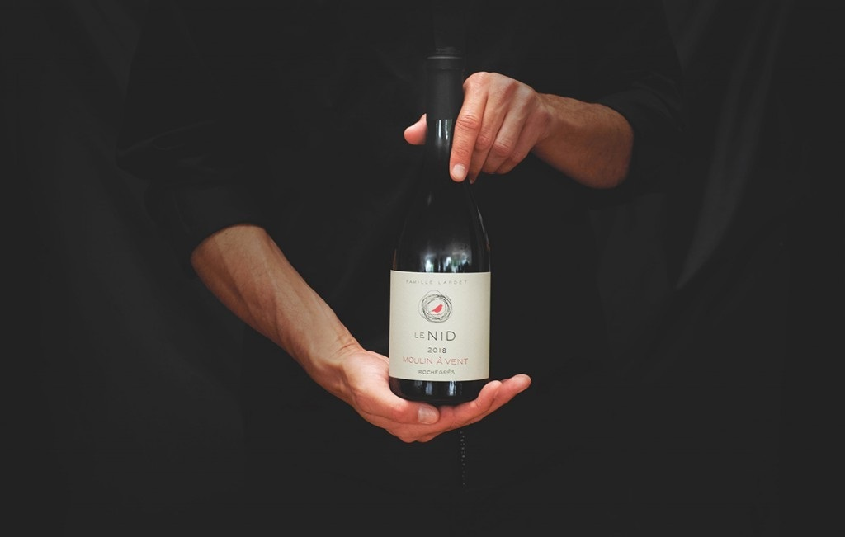
ROCHEGRES

MOULIN À VENT 2018

The dress of this 2018 is a beautiful ruby red with rather deep violin notes. The nose is a nice aromatic power, slightly «roasted» with black cherries notes, violet, grey pepper. The dense mouth presents aromas of cinnamon and vanilla mixed with blackberry, blueberry. Beautiful structure, the tannins are refined and contained by a dense and fruity flesh. This Moulin à Vent must wait a few years to be at its peak. Serve at 14-16°C.
TASTING

APPELLATION — Cru Moulin à Vent LOCATION — Hill of Moulin à Vent in Romaneche-thorins
GR APES
SOIL — Terroir de Moulin-à-Vent is made of granite soil
GRAPE VARIETY — Gamay noir with white juice
SURFACE — 1 hectares
PRODUCTION —2000 bottles/100 magnums PLANTING DENSITY — 10 000 vines / hectare AVERAGE AGE — 75 years
VINE YIELD — 30 hL / hectare
PRUNING — Traditional short, goblet
FARMING MODE — Reasoned farming
PICKING — 100 % by hand

TANKS — Stainless steel vats of 60 hL to refine
WINE-MAKING
plot selection
MACERATION — Traditional wine-making, partial destemming and alcoholic fermentation with maceration of approximately 15 days AGEING — In oak casks over 14 months
BOTTLING — On the Domaine, in autumn

Our family-run Domaine groups together the most prestigious terroirs on the hill of the Appellation d’Origine Contrôlée, Moulin-à-Vent. We respect local tradition and preserve the authenticity of our Gamay vines. The picking is done by hand and we only select the best best grapes.
DOMAINE
Our reasoned farming, plot selection approach and oak barrel ageing techniques produce wines with great structure and an excellent ageing potential. Experience «Le Nid» and discover an elegant wine coming from this exceptional Cru which is often compared to its Bourguignons cousins.

MAISON LE NID - LE MOULIN À VENT - 71570 ROMANECHE THORINS, FRANCE TEL - +33 6 82 88 61 01
www. lenid. fr — contact@lenid.fr

